**Evaluation 1**

**Simple C Programs - Lab 1**

|  |  |
| --- | --- |
| *1.Write a C program to add two integers a and b read through the keyboard. Display the result using* | |
| *third variable sum.* |  |

**Program:**

#include <stdio.h>

int main()

{

int sum,a,b;

printf("My name is Lajith Puthuchery and Registration Number is 200905106\n");

printf("Enter the two integers");

scanf("%d %d", &a, &b);

sum = a + b;

printf("%d + %d = %d ",a,b,sum);

return 0;

}

**Output:**

*2.Write a C program to find the sum, difference, product and quotient of 2 numbers.*

**Program:**

#include <stdio.h>

int main()

{

float a,b,sum,diff,prod,quot;

printf("My name is Lajith Puthuchery and Registration Number is 200905106\n");

printf("Enter two integers");

scanf("%f %f",&a, &b);

sum = a+b;

printf("%.2f + %.2f = %.2f\n",a,b,sum);

diff = a-b;

printf("%.2f - %.2f = %.2f\n",a,b,diff);

prod = a*b;

printf("%.2f * %.2f = %.2f\n",a,b,prod);

if(b == 0)

{

printf("Divison by 0 is not defined");

}

else

{

quot = a/b;

printf("%.2f / %.2f = %.2f\n",a,b,quot);

}

return 0;

}

**Output:**

*3.Write a C program to print the ASCII value of a character*

**Program:**

#include <stdio.h>

int main()

{

char c;

printf("My name is Lajith Puthuchery and Registration Number is 200905106\n");

printf("Enter a character");

scanf("%c",&c);

printf("The ASCII value of %c is %d\n",c,c);

return 0;

}

**Output:**

|  |  |
| --- | --- |
| *4.Write a C program to display the size of the data type int, char, float, double, long int and long* | |
| *double using size of ( ) operator*. |  |

**Program:**

#include <stdio.h>

int main()

{

int intdata;

float floatdata;

char chardata;

double doubledata;

long int longint;

long double longdouble;

printf("My name is Lajith Puthuchery and Registration Number is 200905106\n");

printf("Size of int: %zu bytes\n", sizeof(intdata));

printf("Size of float: %zu bytes\n", sizeof(floatdata));

printf("Size of char: %zu byte\n", sizeof(chardata));

printf("Size of double: %zu bytes\n", sizeof(doubledata));

printf("Size of double: %zu bytes\n", sizeof(longint));

printf("Size of double: %zu bytes\n", sizeof(longdouble));

return 0;

}

**Output:**

*5.Input P, N and R to compute simple and compound interest. [ Hint : SI = PNR/100, CI = P(1+R/100 )N-P]*

**Program:**

#include <stdio.h>

#include <math.h>

int main()

{

int n,r;

float si,ci,p;

printf("My name is Lajith Puthuchery and Registration Number is 200905106\n");

printf("Enter the principal amount, time period and rate of interest respectively");

scanf("%d %d %d",&p,&n,&r);

si = (p*n*r)/100;

ci = p*pow(1+r/100,n)-p;

printf("The Simple Interest is %f\n",si);

printf("The Compound Interest is %f",ci);

return 0;

}

**Output:**

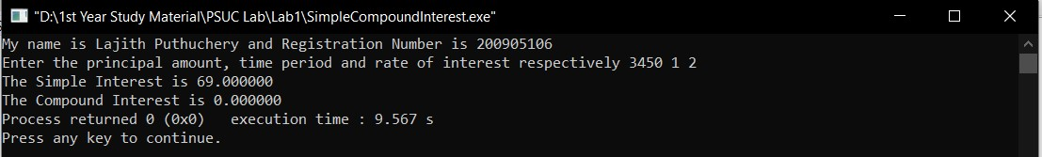

*6.Input radius to find the volume and surface area of a sphere. [Hint: volume = (4πr3)/3, Area=4πr2]*

**Program:**

#include <stdio.h>

#include <math.h>

#define PI 3.142857

int main()

{

int r;

float vol, area;

printf("My name is Lajith Puthuchery and Registration Number is 200905106\n");

printf("Enter the radius of the sphere");

scanf("%d",&r);

vol = (4*PI*pow(r,3))/3;

area = 4*PI*pow(r,2);

printf("The volume of the sphere of radius %d is %f\n",r,vol);

printf("The surface area of the sphere of radius %d is %f",r,area);

return 0;

}

**Output:**

*7.Convert the given temperature in Fahrenheit to Centigrade. [Hint:C=5/9(F-32)]*

**Program:**

#include <stdio.h>

int main()

{

float tempC, tempF;

printf("My name is Lajith Puthuchery and Registration Number is 200905106\n");

printf("Enter the temperature in Fahrenheit");

scanf("%f",&tempF);

tempC = (5.0/9.0)*(tempF-32);

printf("The temprature is %.2fC in Celsius Scale",tempC);

return 0;

}

**Output:**

*8.Write a C program to evaluate the following expression for the values a = 30, b=10, c=5,d=15*

*(i ) (a + b) * c/ d*

1. *((a + b) * c) /d*
2. *a + (b * c)/ d*
3. *(a + b) * (c / d)*

**Program:**

#include <stdio.h>

int main()

{

printf("My name is Lajith Puthuchery and Registration Number is 200905106\n");

int a=30, b=10, c=5, d=15;

int exp1, exp2, exp3, exp4;

exp1 = (a+b)*c/d;

printf("The result of the expression (a+b)*c/d is %d\n",exp1);

exp2 = ((a+b)*c)/d;

printf("The result of the expression ((a+b)*)c/d is %d\n",exp2);

exp3 = a + (b*c)/d;

printf("The result of the expression a+(b*c)/d is %d\n",exp3);

exp4 = (a+b)*(c/d);

printf("The result of the expression (a+b)*(c/d) is %d\n",exp4);

return 0;

}

**Output:**

**Branching Control Structures - Lab 2**

*1.Check whether the given number is odd or even.*

**Program:**

#include <stdio.h>

int main()

{

int num;

printf("My name is Lajith Puthuchery and Registration Number is 200905106\n");

printf("Enter a number");

scanf("%d",&num);

if(num % 2 ==0)

{

printf("%d is an even number",num);

}

else

{

printf("%d is an odd number",num);

}

return 0;

}

**Output:**

2.Find the largest among given 3 numbers.

**Program:**

#include <stdio.h>

int main()

{

printf("My name is Lajith Puthuchery and Registration Number is 200905106\n");

int a,b,c, largest;

printf("Enter three numbers");

scanf("%d %d %d",&a,&b,&c);

if(a > b)

{

if(a>c)

{

largest = a;

}

else

{

largest = c;

}

}

else

{

if(b >c)

{

largest = b;

}

else

{

largest = c;

}

}

printf("The largest of %d, %d and %d is %d",a,b,c,largest);

return 0;

}

**Output:**

3. Swap two numbers without using third variable.

**Program:**

#include <stdio.h>

int main()

{

int a,b;

printf("My name is Lajith Puthuchery and Registration Number is 200905106\n");

printf("Enter the two numbers to be swapped");

scanf("%d %d",&a,&b);

printf("Before swapping\n a = %d\n b = %d\n",a,b);

a = a + b;

b = a - b;

a = a - b;

printf("After swapping\n a = %d\n b = %d",a,b);

return 0;

}

**Output:**

4. Compute all the roots of a quadratic equation using switch case statement. [Hint: x = (-b +/-sqrt(b2-4ac))/2a]

**Program:**

#include <stdio.h>

#include <math.h>

int main()

{

int z;

float a,b,c,disc, root1, root2,x,img,real;

printf("My name is Lajith Puthuchery and Registration Number is 200905106\n");

printf("Enter the values for a, b and c");

scanf("%f %f %f",&a,&b,&c);

disc = b*b - 4*a*c;

x = sqrt(fabs(disc));

if(disc > 0)

{

z=1;

}

else if (disc == 0)

{

z=2;

}

else

{

z=3;

}

switch(z)

{

case 1:

printf("The quadratic equation has 2 real and distinct roots\n");

root1 = -b/(2*a) + x/(2*a);

root2 = -b/(2*a) - x/(2*a);

printf("r1 = %f\nr2 = %f\n",root1,root2);

break;

case 2:

printf("The quadratic equation has 2 real and equal roots\n");

root1 = -b/(2*a);

root2 = root1;

printf("r1 = %f\nr2 = %f\n",root1,root2);

break;

case 3:

printf("The quadratic equation has 2 imaginary roots\n");

real = -b/(2*a);

img = x/(2*a);

printf("r1 = %f + i%f\nr2 = %f - i%f\n",real,img,real,img);

break;

default:

break;

}

return 0;

}

**Output:**

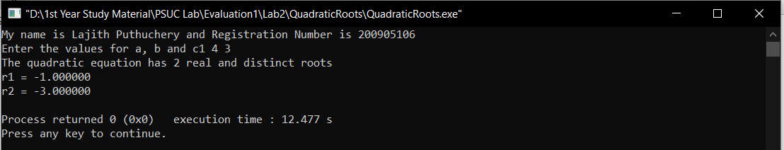

5. Write a program that will read the value of x and evaluate the following function.

Y = 1 if x>0,

0 if x=0,

-1 if x<0

Use else if statements & Print the result (‘Y’ value).

**Program:**

#include <stdio.h>

int main()

{

int x,y;

printf("My name is Lajith Puthuchery and Registration Number is 200905106\n");

printf("Enter the value for x");

scanf("%d",&x);

if(x>0)

{

y=1;

}

else if (x==0)

{

y=0;

}

else

{

y=-1;

}

printf("Y = %d",y);

return 0;

}

**Output:**

6. Find the smallest among three numbers using conditional operator.

**Program:**

#include <stdio.h>

int main()

{

printf("My name is Lajith Puthuchery and Registration Number is 200905106\n");

int a,b,c, smallest;

printf("Enter three numbers");

scanf("%d %d %d",&a,&b,&c);

if(a < b)

{

if(a<c)

{

smallest = a;

}

else

{

smallest = c;

}

}

else

{

if(b < c)

{

smallest = b;

}

else

{

smallest = c;

}

}

printf("The smallest of %d, %d and %d is %d",a,b,c,smallest);

return 0;

}

**Output:**

